
Database Management Lab Sheet (ENCS205)
Bachelor of Technology in Computer Science and Engineering

Submitted by:
Sahdev Sharma (2401010092)
B. Tech CSE (Core) – 4th Semester Section: A

Submitted To:
MS. Mansi Kajal

School of Engineering & Technology
K. R. MANGALAM UNIVERSITY
Sohna, Haryana 122103, India feb-2026

Lab Sheet: 4

Lab Assignment: SQL User Management & Access Control Title:
Implementation of User Creation, Deletion, and Privilege Management in SQL
Problem Statement

Design and execute SQL commands to create users, manage their access privileges, and remove users in a database system. This assignment focuses on database security and access control mechanisms.
Tasks

Part A: User Creation

- Create a new user named user1 with a password.
- Create another user user2 with limited access.
Part B: Granting Privileges

- Grant SELECT and INSERT privileges on a table Student to user1.
- Grant ALL privileges on a table Course to user2.
- Provide WITH GRANT OPTION to user1 and observe its effect.
Part C: Revoking Privileges

- Revoke INSERT permission from user1 on the Student table.
- Revoke all privileges from user2 on the Course table.
Part D: User Deletion

- Drop/Delete user user2 from the database.
- Attempt to login using deleted credentials and observe the result.
Part E: Additional Commands

- Display all users in the system.
- Show privileges assigned to a specific user.

[QUERY]:
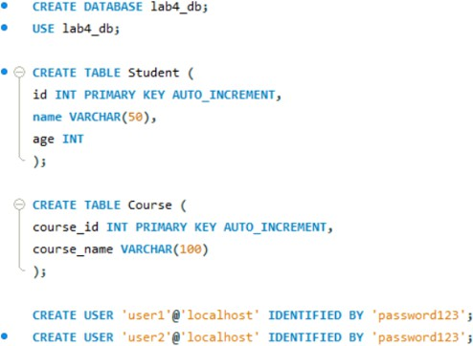

Part A: User Creation

- Create a new user named user1 with a password.
- Create another user user2 with limited access


Part B: Granting Privileges

- Grant SELECT and INSERT privileges on a table Student to user1.
- Grant ALL privileges on a table Course to user2.
- Provide WITH GRANT OPTION to user1 and observe its effect.

Part C: Revoking Privileges

- Revoke INSERT permission from user1 on the Student table.
- Revoke all privileges from user2 on the Course table.

Part D: User Deletion

- Drop/Delete user user2 from the database.
- Attempt to login using deleted credentials and observe the result.

Part E: Additional Commands

- Display all users in the system.
- Show privileges assigned to a specific user.


[OUTPUT]:
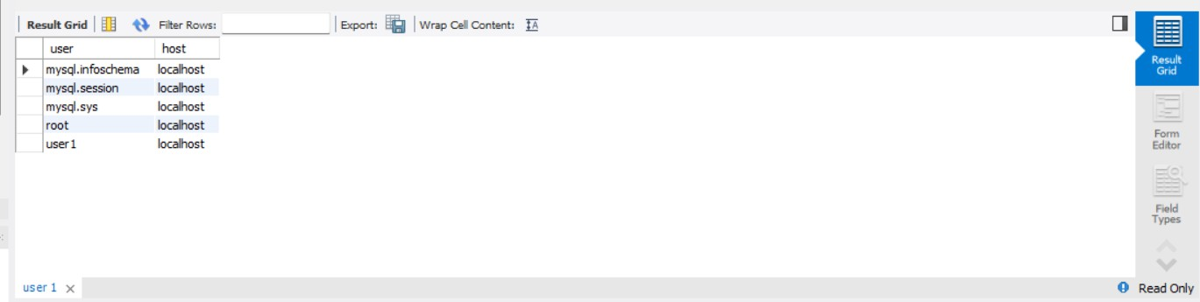

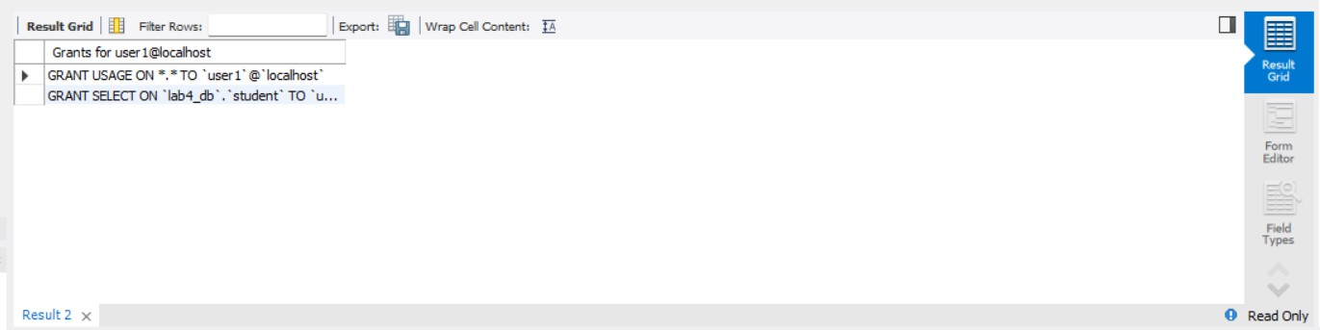

[Observations]:
  - User creation allows controlled access to the database.
  - Privileges can be finely controlled using GRANT and REVOKE.
  - WITH GRANT OPTION enables delegation of permissions.
  - Revoking privileges immediately affects user capabilities.
  - Deleting a user removes all access rights permanently.

[Conclusion]:
This assignment helped in understanding database security mechanisms. SQL provides powerful commands to manage user access and ensure data protection. Proper use of these commands ensures controlled and secure database operations.

